**LAB 2**

**Name :Muahammad Shaheer**

**Roll no:20p-0480**

**LAB task 2**

1. First Configure the PCs as shown and verify the connection using ping command.

**STEPS:**

**1:**First of all using packet tracer use 2 devices and connect them with cross over cable.

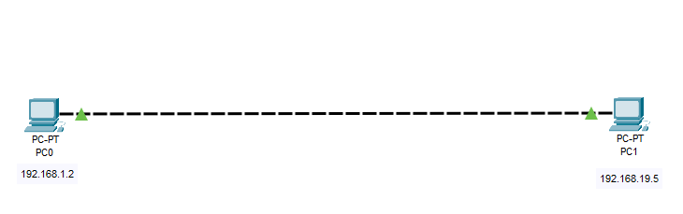

2.Now assign them IP addresses by click on each PC and select Desktop and then navigate towards IP Configuration.

Here for PC 1:

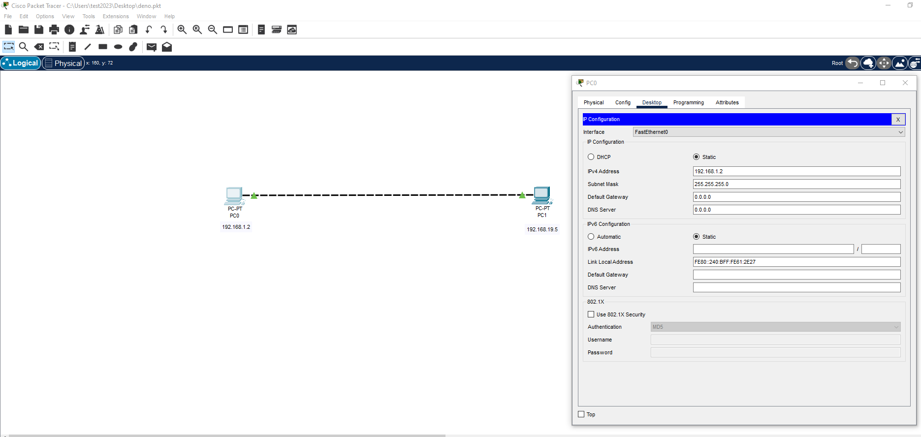

For PC 2:

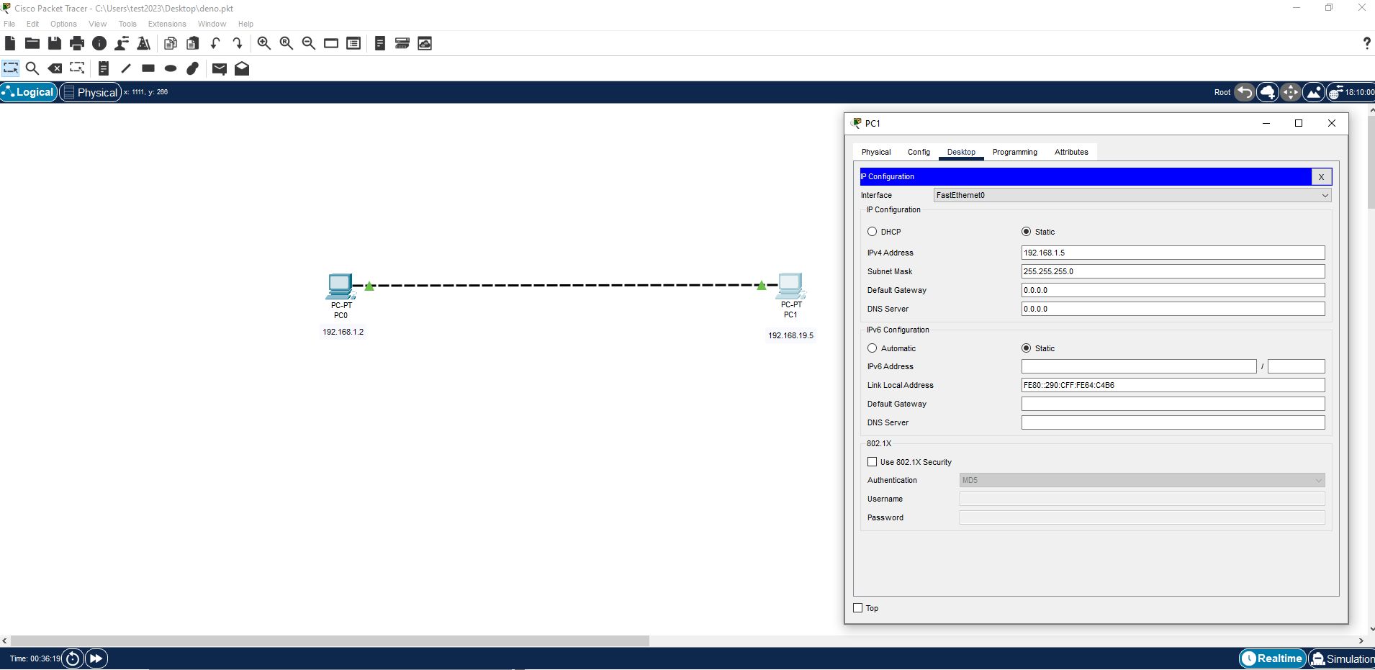

3.Now to ping devices use ping command on command prompt like this :

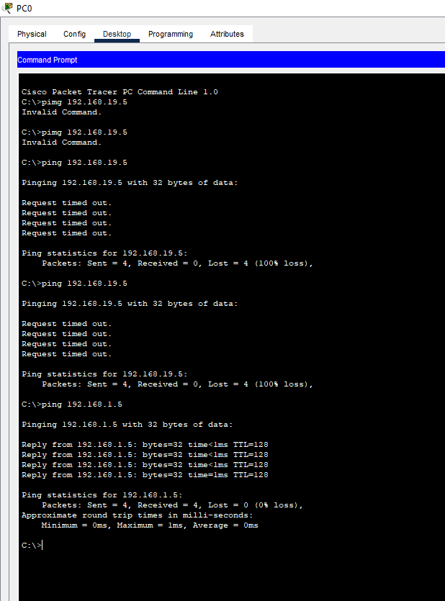

**Explanations:**

So as IP and subnet mask of both devices are valid and accurate so that’s why ping is successfully done.We will check other cases of invalid formats in next parts.

Part b: Configure PC1 as follow: IPv4: 192.168.1.1 Subnet mask: 255.255.255.0

And PC2 as: IPv4: 192.168.2.1 Subnet mask: 255.255.255.0

**STEPS:**

**1:**First of all using packet tracer use 2 devices and connect them with cross over cable.

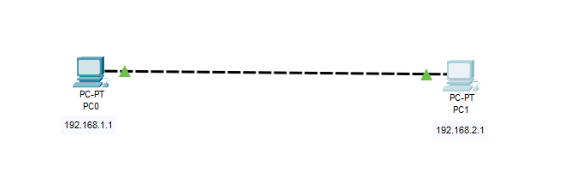

2.Now assign them IP addresses by click on each PC and select Desktop and then navigate towards IP Configuration.

Here for PC 1:

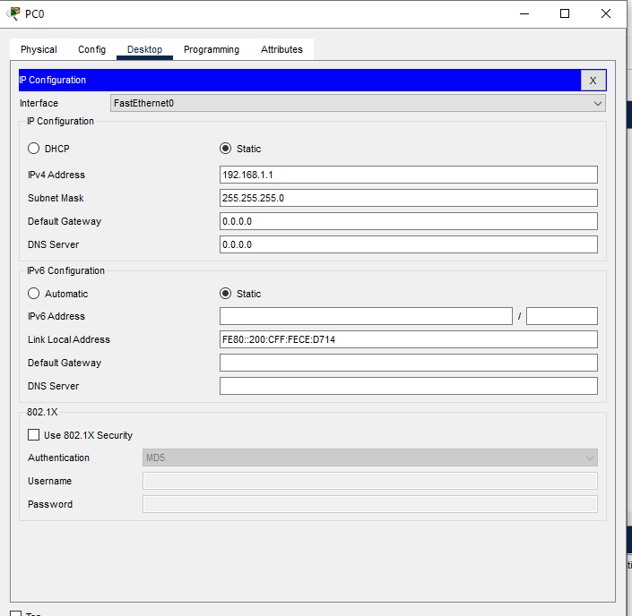

For PC 2:

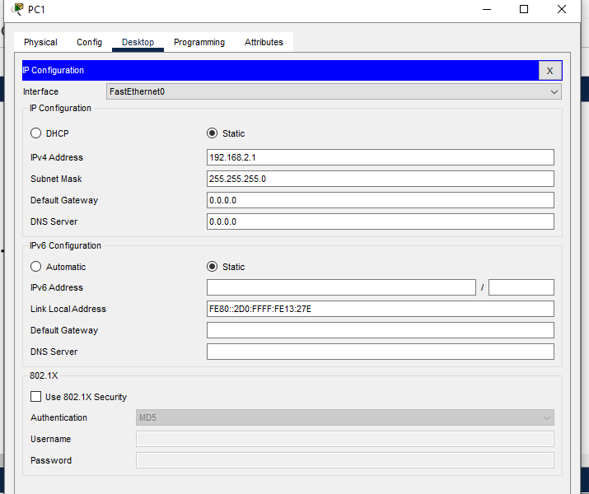

3.Now to ping devices use ping command on command prompt like this :

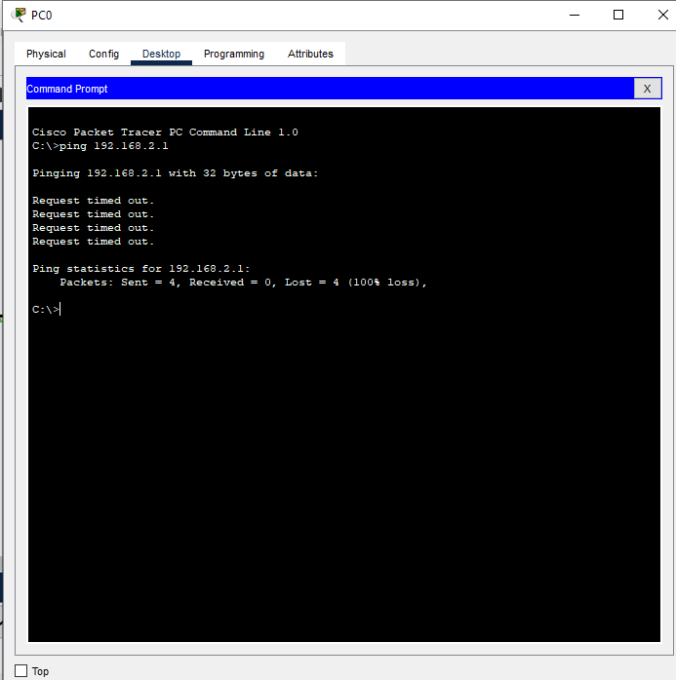

**Explanations:**

So in IP addresses network part of both devices are not same so that’s why ping is not successfully done.

c. Configure PC1 as follow: IPv4: 192.168.1.1 Subnet mask: 255.255.0.0

And PC2 as: IPv4: 192.168.2.1 Subnet mask: 255.255.0.0

Verify each configuration using ping command and briefly describe the response.

**STEPS:**

**1:**First of all using packet tracer use 2 devices and connect them with cross over cable.

2.Now assign them IP addresses by click on each PC and select Desktop and then navigate towards IP Configuration.

Here for PC 1:

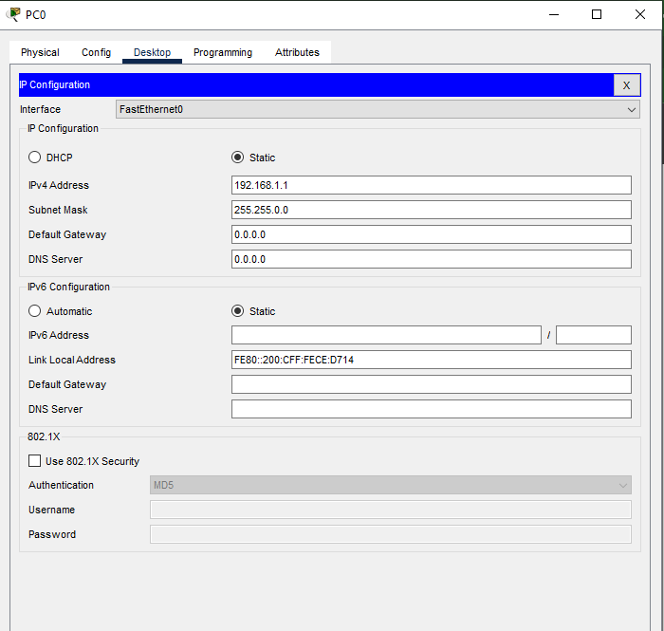

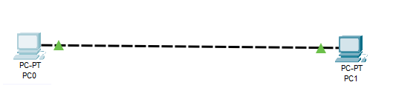For PC 2:

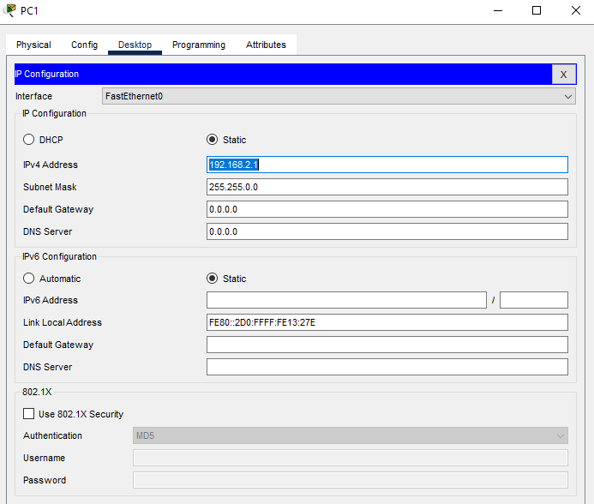

3.Now to ping devices use ping command on command prompt like this :

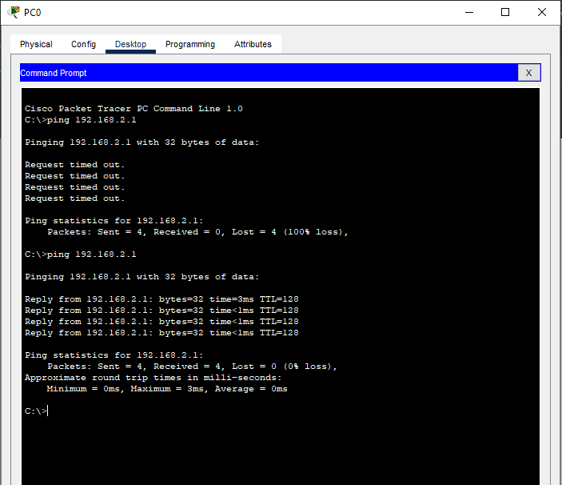

**Explanations:**

So in IP addresses network part of both devices are not same also subnet mask is not valid so that’s why ping is not successfully done.

Task 2: Simulation of a Hub with End Devices in Packet Tracer

o Connect end devices to a hub and observe how the hub forwards network traffic.

o Verify connectivity and communication between end devices connected to the hub.

**Steps:**

1:first of all use hub device from connected devices and take four end devices connect them with straight copper cable and before that assign IP addresses to them as shown in figure:

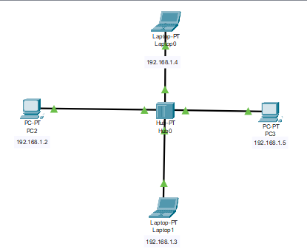

2:Now navigate towards simulation mode and change mode from realtime to simulation mode.

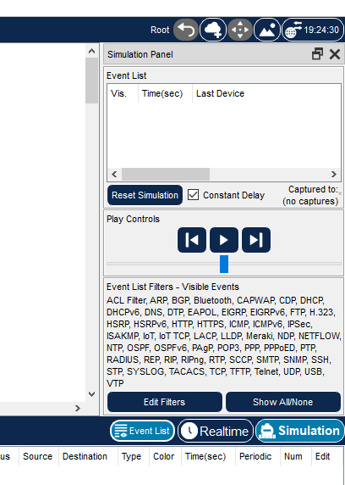

Now click on “add simple pdu” and select sender and reciver by first selecting first device by clicking and then on second click receiver is selected

like this:



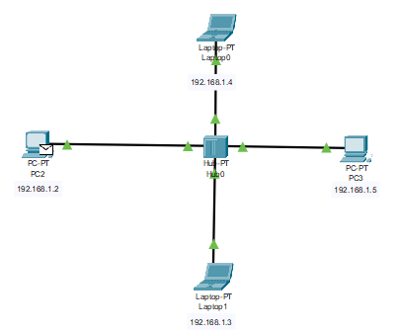

SENDER is selected now

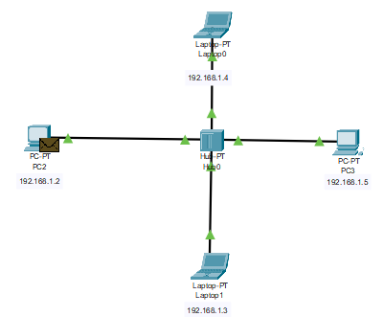

Receiver is selected.

Now we see how message is send by HUB

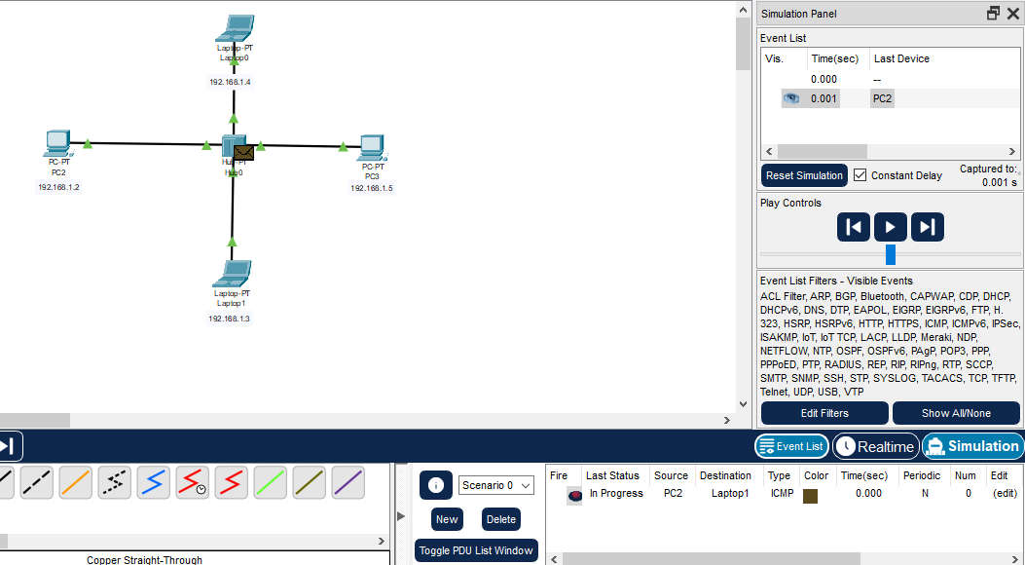

As message is first send to HUB

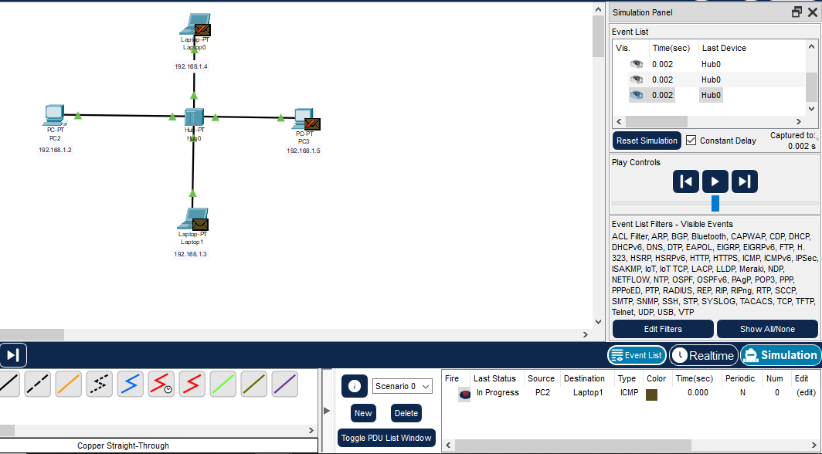

Now from figure it is clear that message is broadcast by Hub to all devices connected but accepted by only one device which we selected as receiver and rejected by other devices

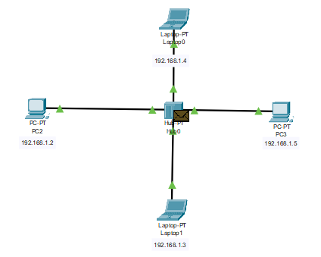

As message is revieved successfully and it acknowledged sender that message is recived and send this to HUB

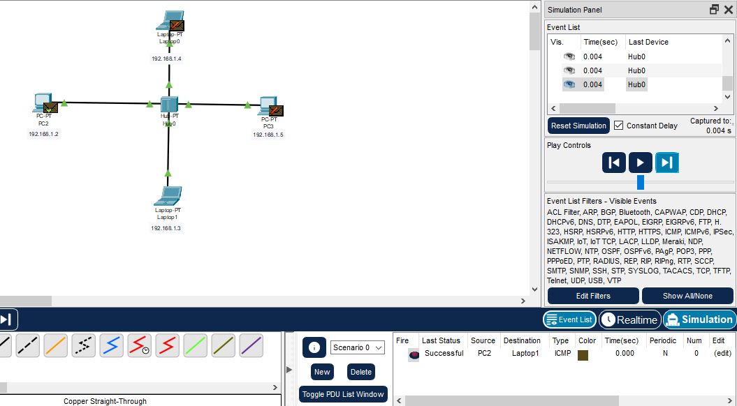

Which is accepted by sender and rejected by other devices as Hub is send this notification to all devices connected to it.

So here we go with successful transmition of message through Hub.

Task 3: Simulation of a Switch with End Devices in Packet Tracer

**Steps:**

1:first of all use Switch device from connected devices and take four end devices connect them with straight copper cable and before that assign IP addresses to them as shown in figure:

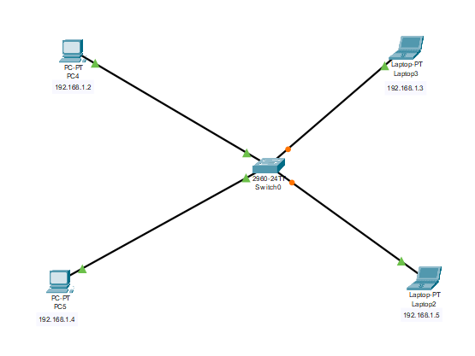

2:Now navigate towards simulation mode and change mode from realtime to simulation mode.



Now click on “add simple pdu” and select sender and reciver by first selecting first device by clicking and then on second click receiver is selected

Selecte sender device now:

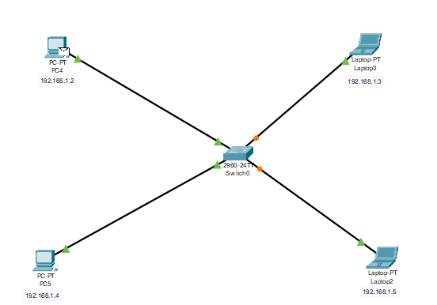

Now select reciver

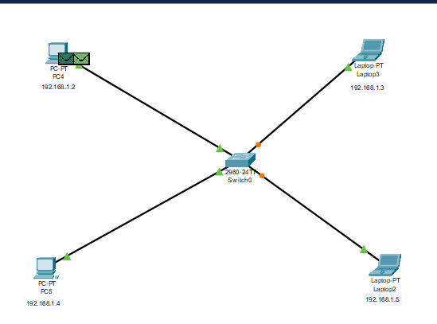

Now start simulation:

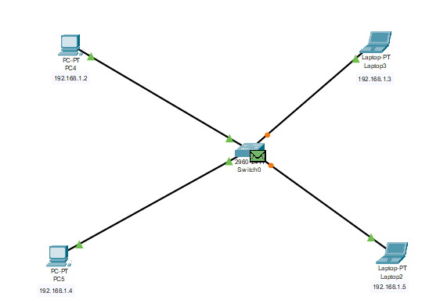

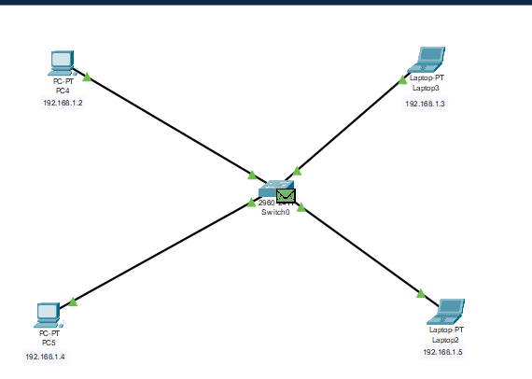

It is successfully done

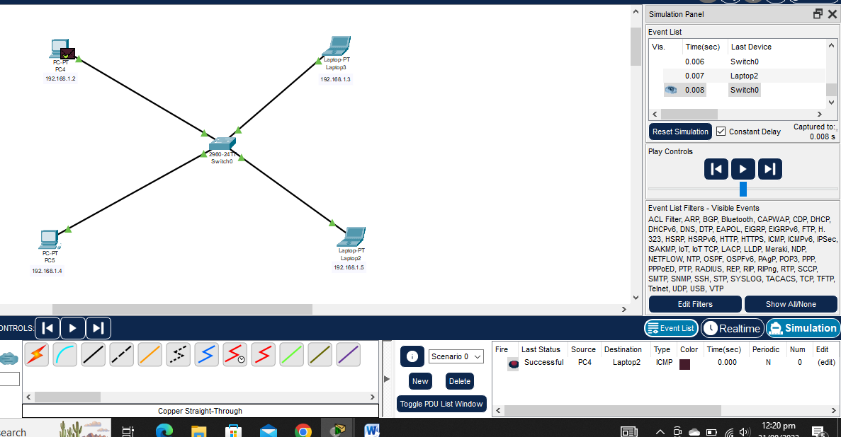

The end___________